**3-2 Milestone Two: Enhancement One: Software Design and Engineering**

Joshua Brown

Department of Computer Science, Southern New Hampshire University

CS – 499: Computer Science Capstone

Mike Alesso, M.Sc.

November 17, 2024

**3-2 Milestone Two: Enhancement One: Software Design and Engineering**

* **Briefly describe the artifact. What is it? When was it created?**
  + The artifact for this milestone is from the final project of Mobile Architecture & Programming Class. In this project, I choose to create an inventory app that allowed a user to create and track their inventory, as well as be notified when an item is out-of-stock. The original project was created on June 30, 2024.
* **Justify the inclusion of the artifact in your ePortfolio. Why did you select this item? What specific components of the artifact showcase your skills and abilities in software development? How was the artifact improved?**
  + I choose to include this artifact, because the proper implementation of the flawed designs would not only showcase my work as a developer, but also show my dedication to a secure and functional application. In particular, I had to add new elements to the User (phone number and salt) and Item tables in my databases (item ID and creator), so that I could pass the user data through the login screen to the inventory screen. This would allow me to filter the data in the Item tables to only display the items of the logged in user.
* **Did you meet the course outcomes you planned to meet with this enhancement in Module One? Do you have any updates to your outcome-coverage plans?**
  + The enhancement went as planned; though I did have to do some mandatory work on the databases ahead of time to get this feature to work as intended; no changes to the outcome-coverage plans. Screenshots of the results below:
  + **Screenshot of logging into one account with that account inventory showing on the screen**
  + 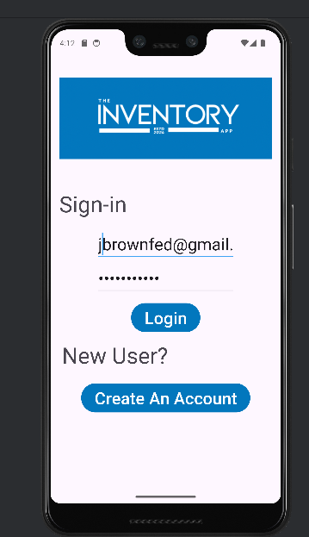A screenshot of a cell phone

    Description automatically generated
  + **Screenshot of logging into another account with that account inventory showing on the screen**
  + 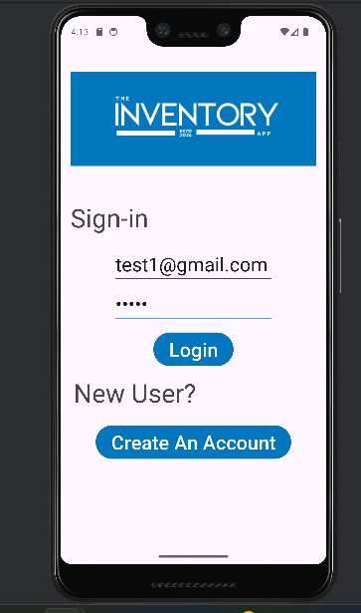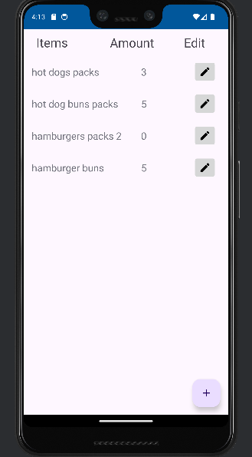
* **Reflect on the process of enhancing and modifying the artifact. What did you learn as you were creating it and improving it? What challenges did you face?**
  + **User Class & Table Update**
    - Added phone and salt variables and getter/setter functions to User class
    - I added an additional constructor of the User class, so I have one with the phone number included and one without. This makes it so that I won’t have to change the form in the New User Activity, but I can add an update phone number form later on the account screen that I will update later.
    - Added functions to automatically generate a random salt upon creation of a new account in User class
    - Made User a serializable class so it could be passed as an object to Inventory Activity.
    - Added phone and salt columns in User Database and updated the version for User table.
    - Thoroughly commented code.
  + **User Repository Update**
    - Refactored create and read methods to include phone and salt
    - Refactored update method to include phone and salt as arguments, and to save phone and salt into the database.
    - Thoroughly commented code
  + **Login Activity Update**
    - If the user successfully logged in, I passed the user as a serializable object to the Inventory Activity.
    - Thoroughly commented code
  + **Item Class & Table Update**
    - Added item ID and creator to Item Class and created getter/setter functions.
    - Added item ID and creator columns to the Item table and made the two of them serve as composite keys. Updated the version of Item Table.
  + **Inventory Repository Update**
    - Refactored Create, Read, Update, and Delete methods to include the new columns. Modified Read method to take creator as an argument, and modified Update and Delete methods to include creator and item ID as an argument. The Read method now filters user data using email.
    - Commented code thoroughly.
  + **Inventory Activity Update**
    - Received user login data and used the user email to filter inventory data to items created by the user.
    - Refactor code such as updating the list to include the same filtering.
    - Thoroughly commented code.
    - ***Extra (this is due later): tried to pass extra data to Item Details Activity so that updates will use the new changes in the Inventory Repository. (Not finished; crashes when the Item Details Activity attempts to load).
  + **Item Detail Update**
    - **\*\*\***Extra (this is due later): tried to refactor the code to include the new changes and update across the item table database. (Not finished, Item Details Activity crashes).